CHAPTER 1
Sexual Reproduction in Flowering Plants
• Sexual Reproduction in Flowering Plants

Reproduction becomes a vital process without which species cannot survive for long. Each individual leaves its progeny by asexual or sexual means. The sexual mode of reproduction enables creation of new variants, so that survival advantage is enhanced.
1.1 | FLOWER — A FASCINATING ORGAN OF ANGIOSPERMS

All flowering plants show sexual reproduction, and the fruits and seeds we use are the end products of sexual reproduction. To a biologist, flowers are morphological and embryological marvels and the sites of sexual reproduction.
The two units of sexual reproduction do not develop in the same place: the male unit develops in the anther and the female unit in the ovary.
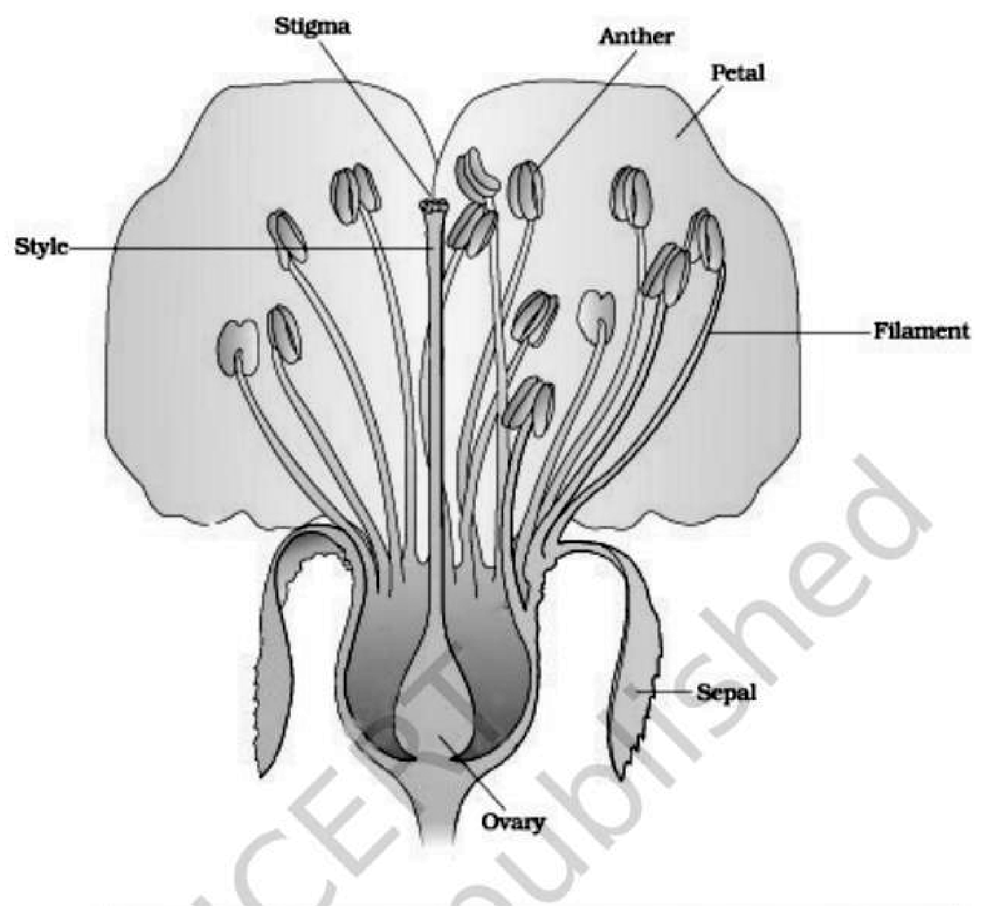
Fig. 1.1 — A diagrammatic representation of L.S. of a flower. Labelled: stigma, style, anther, petal, filament, sepal, ovary.
Profile | SCIENTIST PROFILE

[NOTE] Panchanan Maheshwari (1904-1966). Born in November 1904 in Jaipur (Rajasthan), he became one of the most distinguished botanists of India and of the world. He obtained his D.Sc. at Allahabad, where his interest in botany, especially morphology, was inspired by Dr W. Dudgeon, an American missionary teacher. He worked on embryological aspects and popularised the use of embryological characters in taxonomy. He established the Department of Botany, University of Delhi as an important centre of research in embryology and tissue culture, and emphasised the need for work on the artificial culture of immature embryos. His work on test tube fertilisation and intra-ovarian pollination won worldwide acclaim. He was a Fellow of the Royal Society of London (FRS) and of the Indian National Science Academy, and led the bringing out of the very first Biology textbooks for Higher Secondary Schools published by NCERT in 1964.

1.2 | PRE-FERTILISATION : STRUCTURES AND EVENTS

Much before the actual flower is seen on a plant, the decision that the plant is going to flower has taken place. Several hormonal and structural changes are initiated which lead to the differentiation and further development of the floral primordium. Inflorescences are formed which bear the floral buds and then the flowers.
• The androecium consists of a whorl of stamens representing the male reproductive organ; the gynoecium represents the female reproductive organ.
1.2.1 | Stamen, Microsporangium and Pollen Grain

A typical stamen has two parts — the filament, the long and slender stalk, and the anther, the terminal generally bilobed structure. The proximal end of the filament is attached to the thalamus or the petal of the flower. The number and length of stamens are variable in flowers of different species.
<bullet>• </bullet> A typical angiosperm anther is bilobed, with each lobe having two theca — that is, they are dithecous. Often a longitudinal groove runs lengthwise separating the theca.
<bullet>• </bullet> The anther is a four-sided (tetragonal) structure consisting of four microsporangia located at the corners, two in each lobe. Because it carries four microsporangia, a typical anther is also described as tetrasporangiate.
<bullet>• </bullet> The microsporangia develop further and become pollen sacs. They extend longitudinally all through the length of an anther and are packed with pollen grains.
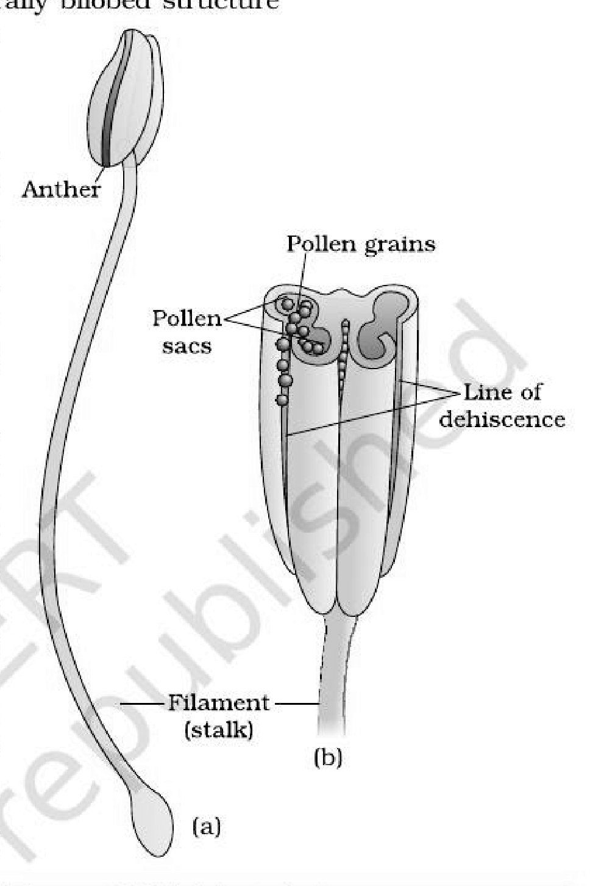
Fig. 1.2 — (a) A typical stamen; (b) three-dimensional cut section of an anther. Labelled: anther, pollen grains, pollen sacs, line of dehiscence, filament (stalk).
1.2.1 | Structure of microsporangium

In a transverse section, a typical microsporangium appears near circular in outline. It is generally surrounded by four wall layers — the epidermis, endothecium, middle layers and the tapetum.
Wall layer (outside to inside) | Function
Epidermis | One of the outer three layers: protection, and helps in dehiscence of the anther to release the pollen
Endothecium | As above — protection and dehiscence
Middle layers | As above — protection and dehiscence
Tapetum (innermost) | Nourishes the developing pollen grains. Its cells possess dense cytoplasm and generally have more than one nucleus

When the anther is young, a group of compactly arranged homogenous cells called the sporogenous tissue occupies the centre of each microsporangium.
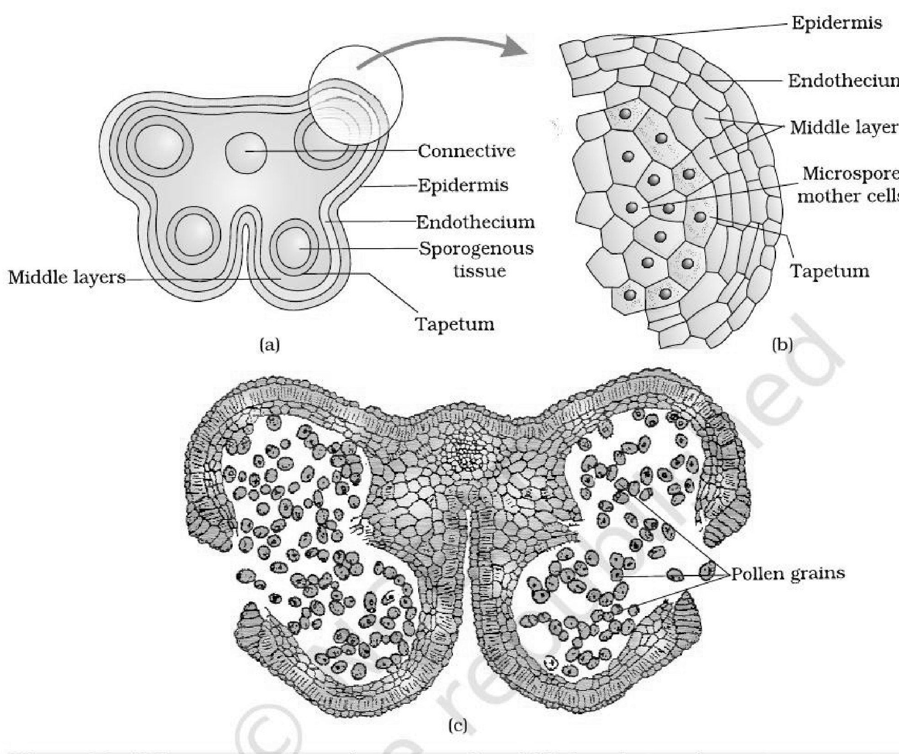
Fig. 1.3 — (a) Transverse section of a young anther; (b) Enlarged view of one microsporangium showing wall layers; (c) A mature dehisced anther. Labelled: connective, epidermis, endothecium, sporogenous tissue, tapetum, middle layers, microspore mother cells, pollen grains.
1.2.1 | Microsporogenesis

As the anther develops, the cells of the sporogenous tissue undergo meiotic divisions to form microspore tetrads. Each such cell is a potential pollen or microspore mother cell.
• Microsporogenesis — the process of formation of microspores from a pollen mother cell (PMC) through meiosis.
1 | Sporogenous tissue in the centre of the microsporangium: compact, homogenous cells, each a potential pollen mother cell (PMC) or microspore mother cell.
2 | Meiosis in the PMC.
3 | Microspore tetrad — the microspores, as they are formed, are arranged in a cluster of four cells.
4 | As the anthers mature and dehydrate, the microspores dissociate from each other and develop into pollen grains.
5 | Inside each microsporangium several thousands of microspores or pollen grains are formed, and they are released with the dehiscence of the anther.

1.2.1 | Pollen grain

The pollen grains represent the male gametophytes. Pollen grains are generally spherical, measuring about 25-50 micrometers in diameter. It has a prominent two-layered wall.
<bullet>• </bullet> Exine — the hard outer layer, made up of sporopollenin, which is one of the most resistant organic material known. It can withstand high temperatures and strong acids and alkali, and no enzyme that degrades sporopollenin is so far known.
<bullet>• </bullet> The exine has prominent apertures called germ pores where sporopollenin is absent. Because of the presence of sporopollenin, pollen grains are well-preserved as fossils. The exine exhibits a fascinating array of patterns and designs, so pollen of different species varies in size, shape, colour and design (Fig. 1.4).
<bullet>• </bullet> Intine — the inner wall of the pollen grain, a thin and continuous layer made up of cellulose and pectin.
<bullet>• </bullet> The cytoplasm of the pollen grain is surrounded by a plasma membrane.
Contents of a mature pollen grain. When the pollen grain is mature it contains two cells, the vegetative cell and the generative cell.
Cell | Size and contents
Vegetative cell | Bigger; has abundant food reserve and a large irregularly shaped nucleus
Generative cell | Small, and floats in the cytoplasm of the vegetative cell; spindle shaped with dense cytoplasm and a nucleus

<bullet>• </bullet> In over 60 per cent of angiosperms, pollen grains are shed at this 2-celled stage.
<bullet>• </bullet> In the remaining species, the generative cell divides mitotically to give rise to the two male gametes before pollen grains are shed (3-celled stage).
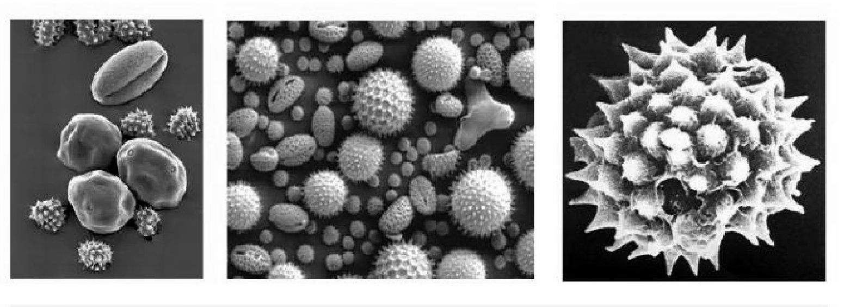
Fig. 1.4 — Scanning electron micrographs of a few pollen grains. The micrographs show the sculptured exine of pollen of different species; this plate carries no in-figure labels.
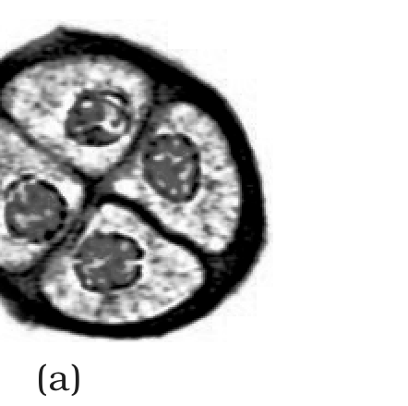 | 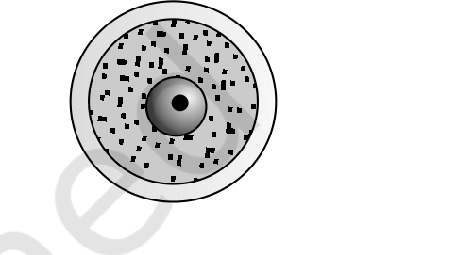 | 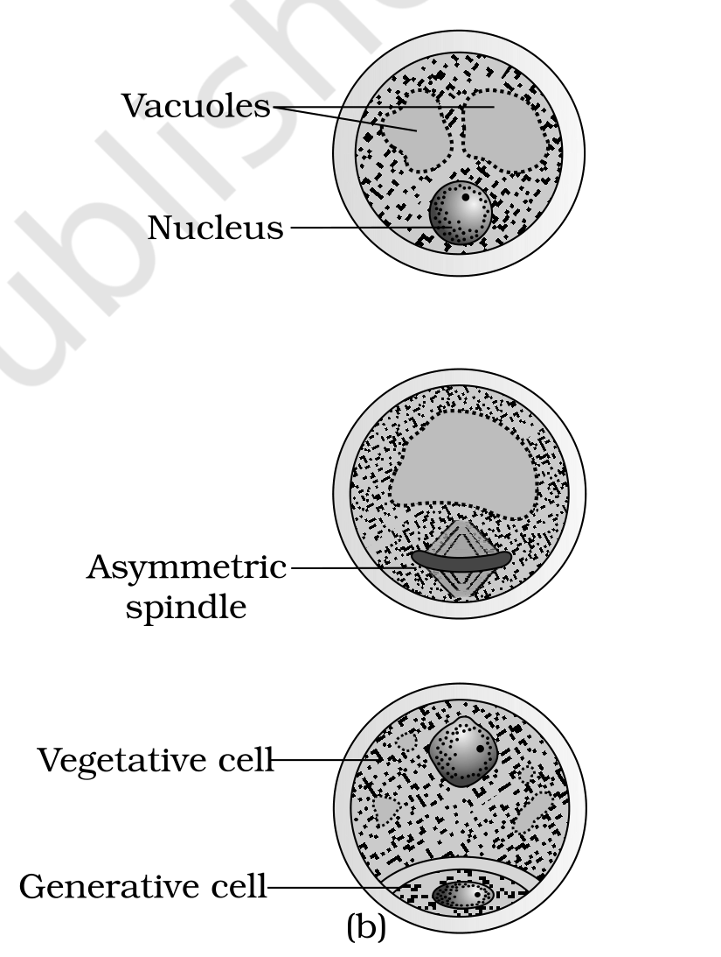
Fig. 1.5 — (a) Enlarged view of a pollen grain tetrad; (b) stages of a microspore maturing into a pollen grain. Labelled: vacuoles, nucleus, asymmetric spindle, vegetative cell, generative cell.
[NOTE] Pollen grains of many species cause severe allergies and bronchial afflictions, leading to chronic respiratory disorders — asthma, bronchitis, etc. Parthenium or carrot grass, which came into India as a contaminant with imported wheat, has become ubiquitous and causes pollen allergy.

Pollen grains are rich in nutrients. Pollen tablets are used as food supplements, and such consumption is claimed to increase the performance of athletes and race horses.
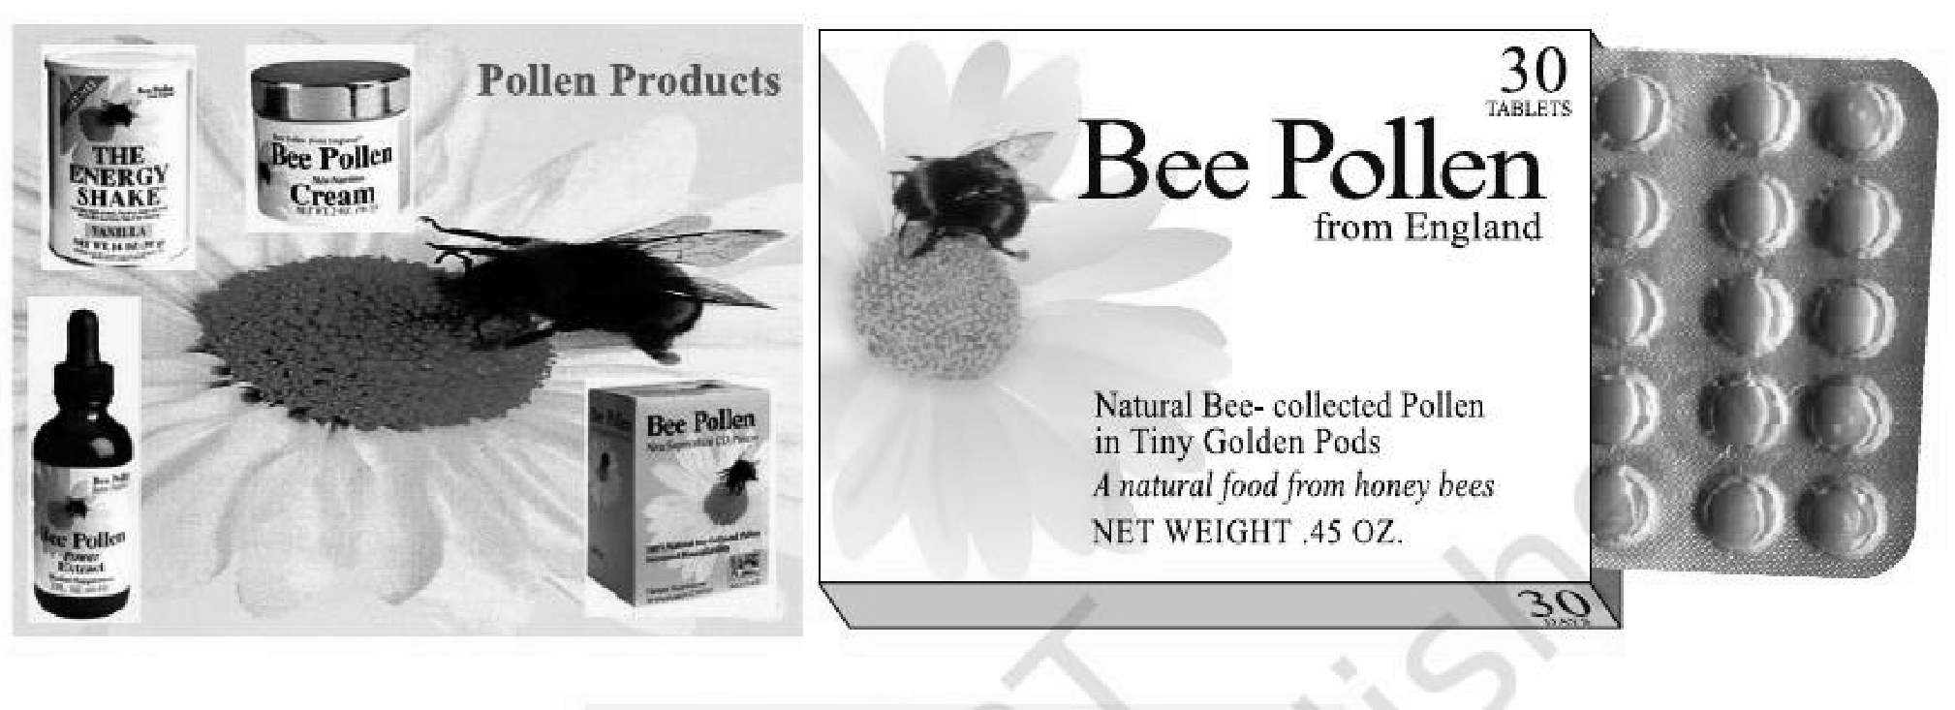
Fig. 1.6 — Pollen products. The plate shows commercial pollen tablets and syrups sold as food supplements; it carries no in-figure labels.
Viability of pollen grains. Pollen grains have to land on the stigma before they lose viability if they have to bring about fertilisation. The period for which pollen grains remain viable is highly variable and to some extent depends on the prevailing temperature and humidity.
Group | Viability of shed pollen
Some cereals — rice, wheat | Lose viability within 30 minutes of release
Some members of Rosaceae, Leguminoseae and Solanaceae | Maintain viability for months
Stored pollen (a large number of species) | Can be stored for years in liquid nitrogen (minus 196 degrees C); such stored pollen is used as pollen banks, similar to seed banks, in crop breeding programmes

1.2.2 | The Pistil, Megasporangium (ovule) and Embryo sac

The gynoecium represents the female reproductive part of the flower. The gynoecium may consist of a single pistil (monocarpellary) or may have more than one pistil (multicarpellary). When there is more than one, the pistils may be fused together (syncarpous) or may be free (apocarpous).
Each pistil has three parts — the stigma, style and ovary.
<bullet>• </bullet> Stigma — serves as a landing platform for pollen grains.
<bullet>• </bullet> Style — the elongated slender part beneath the stigma.
<bullet>• </bullet> Ovary — the basal bulged part of the pistil. Inside the ovary is the ovarian cavity (locule), and the placenta is located inside the ovarian cavity.
<bullet>• </bullet> Arising from the placenta are the megasporangia, commonly called ovules. The number of ovules in an ovary may be one (wheat, paddy, mango) to many (papaya, water melon, orchids).
[NOTE] Class XI recall — placentation. The arrangement of ovules on the placenta inside the ovary is called placentation, and its types (marginal, axile, parietal, basal, free central) were studied with flower morphology in Class XI; this chapter assumes that recall and does not redefine them.

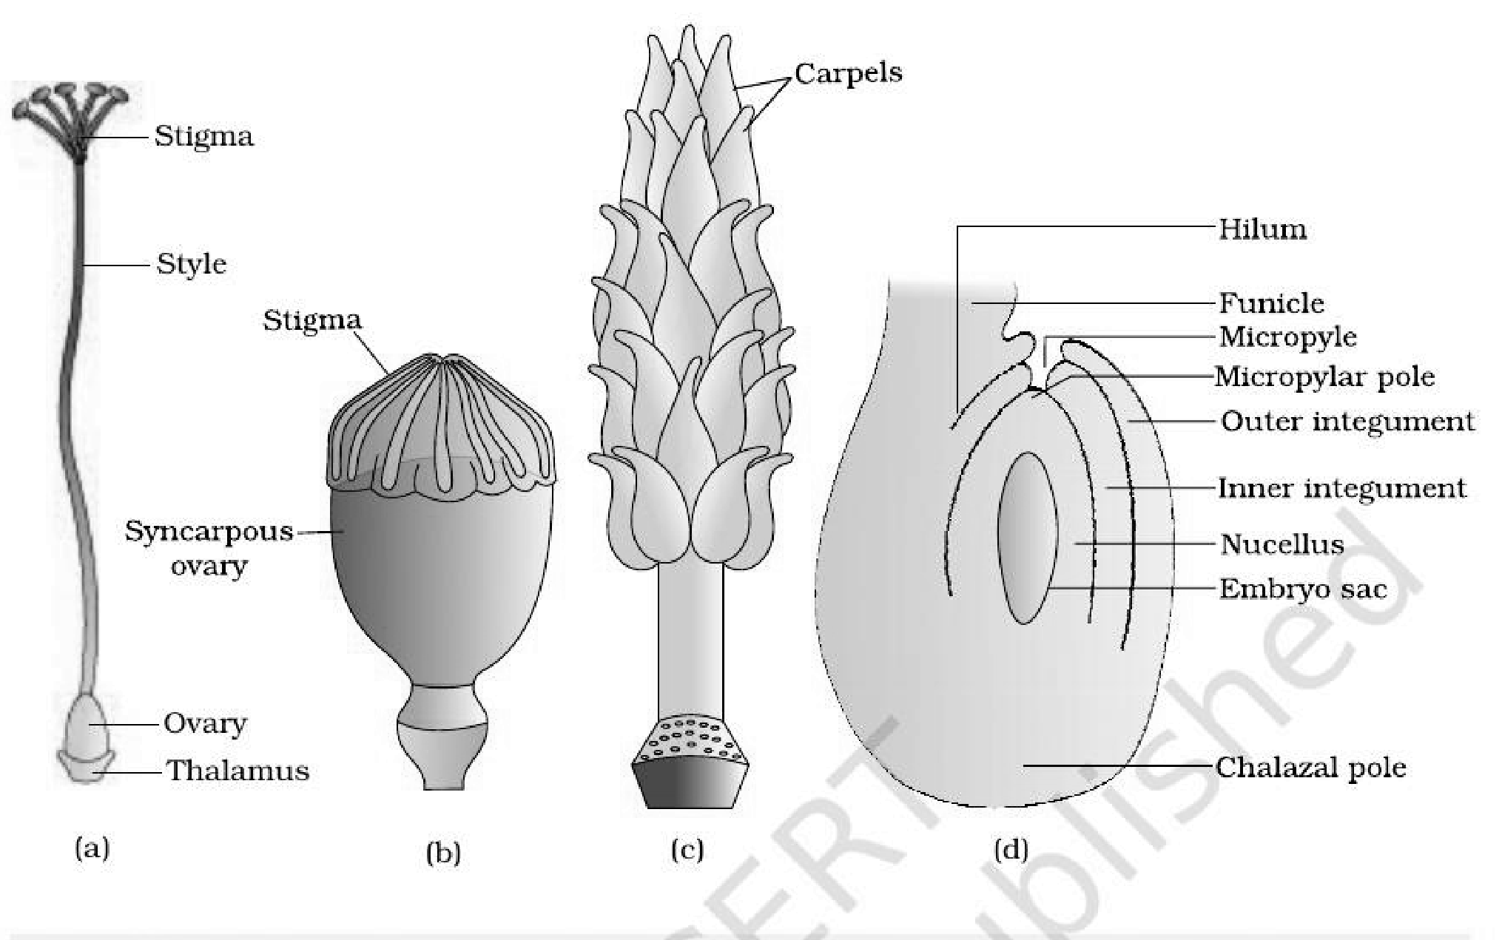
Fig. 1.7 — (a) A dissected flower of Hibiscus showing pistil (other floral parts have been removed); (b) Multicarpellary, syncarpous pistil of Papaver; (c) A multicarpellary, apocarpous gynoecium of Michelia; (d) A diagrammatic view of a typical anatropous ovule. Labelled: stigma, style, ovary, thalamus, syncarpous ovary, carpels, hilum, funicle, micropyle, micropylar pole, outer integument, inner integument, nucellus, embryo sac, chalazal pole.
1.2.2 | The Megasporangium (Ovule)

<bullet>• </bullet> The ovule is a small structure attached to the placenta by means of a stalk called funicle.
<bullet>• </bullet> The body of the ovule fuses with the funicle in the region called hilum; thus, hilum represents the junction between ovule and funicle.
<bullet>• </bullet> Each ovule has one or two protective envelopes called integuments. Integuments encircle the nucellus except at the tip, where a small opening called the micropyle is organised.
<bullet>• </bullet> Opposite the micropylar end is the chalaza, representing the basal part of the ovule.
<bullet>• </bullet> Enclosed within the integuments is a mass of cells called the nucellus. Cells of the nucellus have abundant reserve food materials. It is within this central nucellar tissue that the archesporium differentiates, and a cell of the archesporium becomes the megaspore mother cell.
<bullet>• </bullet> Located in the nucellus is the embryo sac or female gametophyte. An ovule generally has a single embryo sac formed from a megaspore.
1.2.2 | Megasporogenesis

• Megasporogenesis — the process of formation of megaspores from the megaspore mother cell.
<bullet>• </bullet> Ovules generally differentiate a single megaspore mother cell (MMC) in the micropylar region of the nucellus. It is a large cell containing dense cytoplasm and a prominent nucleus.
<bullet>• </bullet> The MMC undergoes meiotic division. Meiosis results in the production of four megaspores.
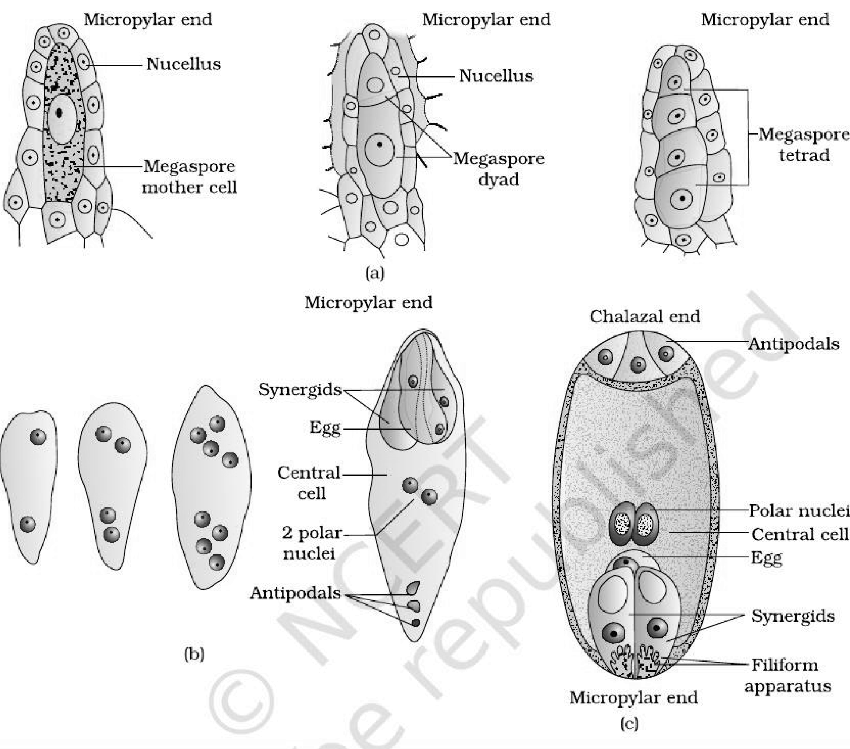
Fig. 1.8 — (a) Parts of the ovule showing a large megaspore mother cell, a dyad and a tetrad of megaspores; (b) 2, 4, and 8-nucleate stages of embryo sac and a mature embryo sac; (c) A diagrammatic representation of the mature embryo sac. Labelled: micropylar end, nucellus, megaspore mother cell, megaspore dyad, megaspore tetrad, synergids, egg, central cell, 2 polar nuclei, antipodals, chalazal end, polar nuclei, filiform apparatus.
1.2.2 | Female gametophyte

In a majority of flowering plants, one of the megaspores is functional while the other three degenerate. Only the functional megaspore develops into the female gametophyte (embryo sac); this method of development of the embryo sac from a single megaspore is termed monosporic development.
1 | Functional megaspore — its nucleus divides mitotically to form two nuclei which move to the opposite poles, forming the 2-nucleate embryo sac.
2 | Two more sequential mitotic nuclear divisions result in the formation of the 4-nucleate and later the 8-nucleate stages of the embryo sac. These mitotic divisions are strictly free nuclear — that is, nuclear divisions are not followed immediately by cell wall formation.
3 | After the 8-nucleate stage, cell walls are laid down, leading to the organisation of the typical female gametophyte or embryo sac.
4 | Six of the eight nuclei are surrounded by cell walls and organised into cells; the remaining two nuclei, called polar nuclei, are situated below the egg apparatus in the large central cell.

Position in the embryo sac | Cells | Notes
Micropylar end | Egg apparatus — three cells grouped together: two synergids and one egg cell | The synergids have special cellular thickenings at the micropylar tip called the filiform apparatus, which play an important role in guiding the pollen tubes into the synergid
Chalazal end | Three cells called the antipodals | —
Centre | The large central cell | Has two polar nuclei

[NOTE] A typical angiosperm embryo sac, at maturity, though 8-nucleate is 7-celled — six organised cells (2 synergids + 1 egg + 3 antipodals) plus the one large central cell that still holds two free polar nuclei.

[MEMORY AID - not in NCERT] Embryo sac census — "2 + 1 + 3 + 1 = 7 cells, 8 nuclei": 2 synergids, 1 egg, 3 antipodals, 1 central cell; the central cell alone carries 2 nuclei, which is where the extra nucleus comes from.

1.2.3 | Pollination

Both types of gametes are non-motile, so they have to be brought together for fertilisation.
• Pollination — transfer of pollen grains (shed from the anther) to the stigma of a pistil.
1.2.3 | Kinds of Pollination

Depending on the source of pollen, pollination can be divided into three types.
Type | Pollen travels from ... to ... | Genetic consequence
Autogamy | Anther to the stigma of the same flower | Self-pollination
Geitonogamy | Anther to the stigma of another flower of the same plant | Functionally cross-pollination (needs a pollinating agent), but genetically similar to autogamy, since the pollen grains come from the same plant
Xenogamy | Anther to the stigma of a different plant | The only type of pollination which during pollination brings genetically different types of pollen grains to the stigma

1.2.3 | Autogamy

In this type, pollination is achieved within the same flower — pollen is transferred from the anther to the stigma of the same flower. In a normal flower which opens and exposes the anthers and the stigma, complete autogamy is rather rare. Autogamy in such flowers requires synchrony in pollen release and stigma receptivity, and also, the anthers and the stigma should lie close to each other.
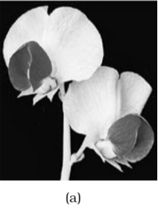 | 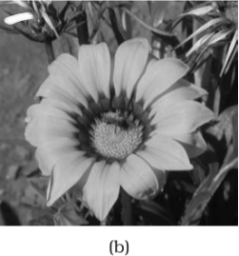 | 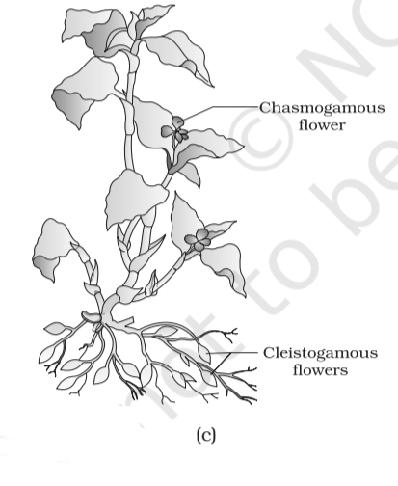
Fig. 1.9 — (a) Self-pollinated flowers; (b) Cross-pollinated flowers; (c) Cleistogamous flowers.
Some plants such as Viola (common pansy), Oxalis and Commelina produce two kinds of flowers:
<bullet>• </bullet> Chasmogamous flowers — similar to flowers of other species, with exposed anthers and stigma. The chasmogamous flower is the one labelled in Fig. 1.9 (above) alongside the closed cleistogamous flowers.
<bullet>• </bullet> Cleistogamous flowers — which do not open at all. In such flowers the anthers and stigma lie close to each other; when anthers dehisce in the flower buds, pollen grains come in contact with the stigma to effect pollination. Cleistogamous flowers are invariably autogamous, as there is no chance of cross-pollen landing on the stigma, and they produce assured seed-set even in the absence of pollinators.
1.2.3 | Geitonogamy

Transfer of pollen grains from the anther to the stigma of another flower of the same plant. Although geitonogamy is functionally cross-pollination involving a pollinating agent, genetically it is similar to autogamy since the pollen grains come from the same plant.
1.2.3 | Xenogamy

Transfer of pollen grains from anther to the stigma of a different plant. This is the only type of pollination which during pollination brings genetically different types of pollen grains to the stigma.
1.2.3 | Agents of Pollination

Plants use two abiotic (wind and water) and one biotic (animals) agents to achieve pollination. Majority of plants use biotic agents for pollination; only a small proportion of plants use abiotic agents.
Because pollen transfer by abiotic agents is not directed towards the target, the flowers produce enormous amount of pollen when compared to the number of ovules available for pollination.
Abiotic agent | Facts to remember
Wind | Pollination by wind is more common amongst abiotic pollinations. It requires pollen grains that are light and non-sticky. Such flowers often possess well-exposed stamens so that the pollen is easily dispersed, and a large often-feathery stigma to easily trap air-borne pollen grains. Wind-pollinated flowers often have a single ovule in each ovary and numerous flowers packed into an inflorescence; a familiar example is the corn cob: its ears are the stigma and style, which wave in the wind to trap pollen grains. Wind-pollination is quite common in grasses.
Water | Pollination by water is quite rare in flowering plants and is limited to about 30 genera, mostly monocotyledons. (Water is, however, a regular mode of transport for the male gametes among the lower plant groups such as algae, bryophytes and pteridophytes.) Examples: Vallisneria and Hydrilla, and several marine sea-grasses such as Zostera. In Vallisneria, the female flower reaches the surface of water by its long stalk and the male flowers or pollen grains are released on to the surface of water. In another group, such as seagrasses, female flowers remain submerged in water and the pollen grains are released inside the water; in these the pollen is long, ribbon like. In most of the water-pollinated species, pollen grains are protected from wetting by a mucilaginous covering.

[NOTE] Both wind and water pollinated flowers are not very colourful and do not produce nectar.

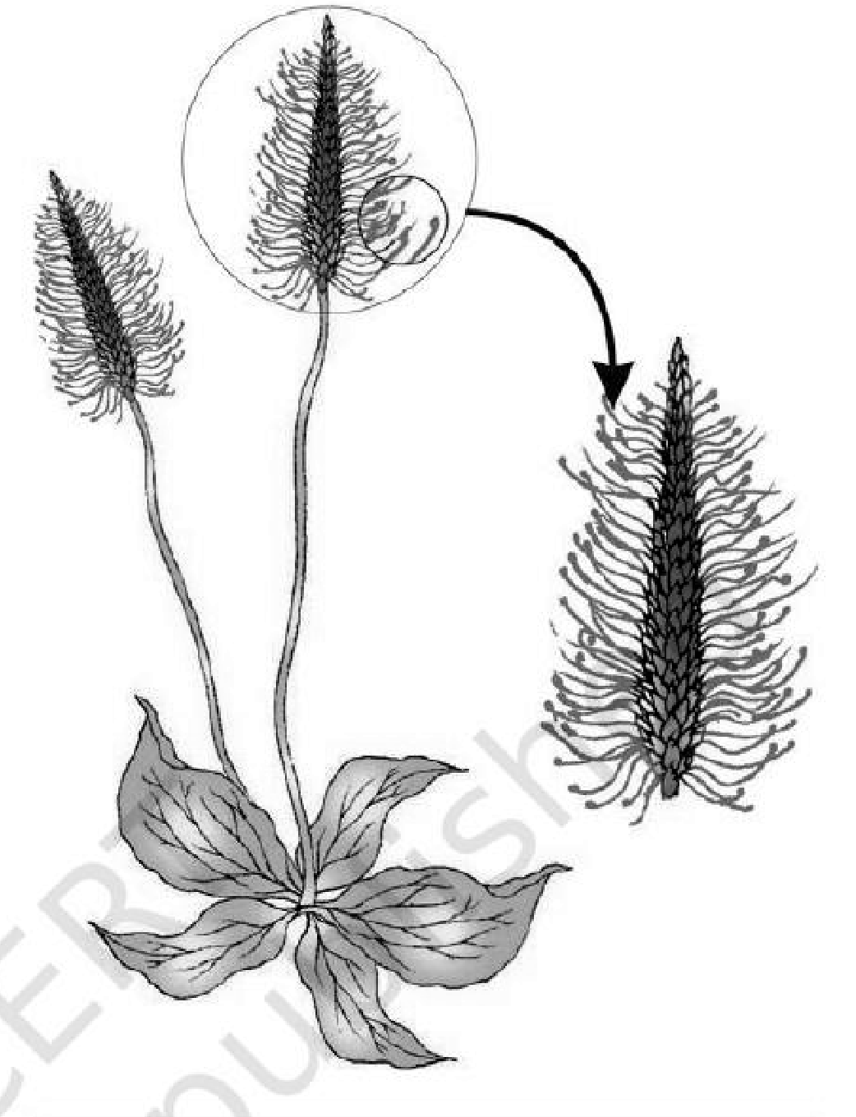
Fig. 1.10 — A wind-pollinated plant showing compact inflorecence and well-exposed stamens. This photographic plate carries no in-figure labels.
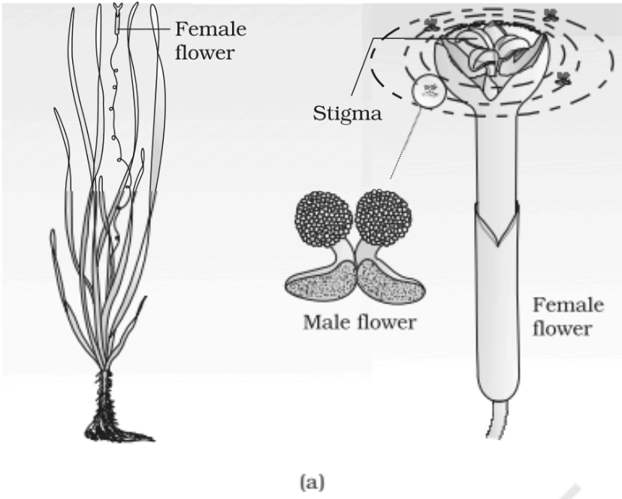 | 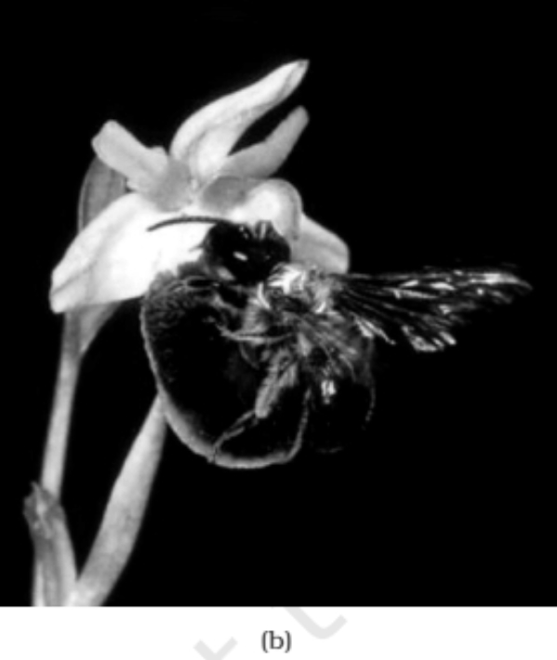
Fig. 1.11 — (a) Pollination by water in Vallisneria; (b) Insect pollination. Labelled: female flower, stigma, male flower.
Water-pollination distinctions. The need for water to transport male gametes and complete fertilisation may limit the distribution of some bryophytes and pteridophytes. Vallisneria and Hydrilla grow in fresh water; Zostera is marine. Not all aquatic plants use water for pollination: water hyacinth and water lily have flowers above water, pollinated by insects or wind. In Vallisneria, pollen is carried passively by water currents to the female flowers; in seagrasses long, ribbon-like pollen moves inside the water.
Biotic agents (animals). Bees, butterflies, flies, beetles, wasps, ants, moths, birds (sunbirds and humming birds) and bats are the common pollinating agents. Among the animals, insects, particularly bees are the dominant biotic pollinating agents. Even larger animals such as some primates (lemurs), arboreal (tree-dwelling) rodents, or even reptiles (gecko lizard and garden lizard) have also been reported as pollinators in some species. Flowers are often adapted to a particular animal species; animals are attracted by colour and/or fragrance, and floral rewards sustain their visits.
<bullet>• </bullet> Majority of insect-pollinated flowers are large, colourful, fragrant and rich in nectar. When the flowers are small, a number of flowers are clustered into an inflorescence to make them conspicuous.
<bullet>• </bullet> The flowers pollinated by flies and beetles secrete foul odours to attract these animals.
<bullet>• </bullet> Nectar and pollen grains are the usual floral rewards. Pollen of animal-pollinated flowers is generally sticky, so the visiting animal gets a coating of pollen on its body and brings about pollination on contact with the stigma of the next flower.
<bullet>• </bullet> In some species floral rewards are in providing safe places to lay eggs; an example is that of the tallest flower of Amorphophallus (the flower itself is about 6 feet in height).
<bullet>• </bullet> A similar relationship exists between a species of moth and the plant Yucca, where both species — moth and the plant — cannot complete their life cycles without each other. The moth deposits eggs in the ovary locule while pollinating the flower; its larvae hatch as the seeds develop.
<bullet>• </bullet> Many floral visitors consume pollen or nectar without bringing about pollination. Such floral visitors are referred to as pollen/nectar robbers.
1.2.3 | Outbreeding Devices

Majority of flowering plants produce hermaphrodite flowers and pollen grains are likely to come in contact with the stigma of the same flower. Continued self-pollination result in inbreeding depression. Flowering plants have therefore developed many devices to discourage self-pollination and to encourage cross-pollination.
Device | How it prevents selfing
1. Non-synchrony | Pollen release and stigma receptivity are not synchronised — either the pollen is released before the stigma becomes receptive, or the stigma becomes receptive much before the release of pollen
2. Different positions | The anther and stigma are placed at different positions so that the pollen cannot come in contact with the stigma of the same flower. Both these devices prevent autogamy.
3. Self-incompatibility | A genetic mechanism; it prevents self-pollen (from the same flower or other flowers of the same plant) from fertilising the ovules by inhibiting pollen germination or pollen tube growth in the pistil
4. Unisexual flowers | Production of unisexual flowers. If both male and female flowers are present on the same plant (monoecious, as in castor and maize), autogamy is prevented but not geitonogamy. If male and female flowers are on different plants (dioecious, as in papaya), both autogamy and geitonogamy are prevented

1.2.3 | Pollen-pistil Interaction

Pollination does not guarantee the transfer of the right type of pollen (compatible pollen of the same species as the stigma). The pistil has the ability to recognise the pollen, whether it is of the right type (compatible) or of the wrong type (incompatible), from another species or from the same plant if self-incompatible.
<bullet>• </bullet> If it is of the right type, the pistil accepts the pollen and promotes post-pollination events that leads to fertilisation.
<bullet>• </bullet> If the pollen is of the wrong type, the pistil rejects the pollen by preventing pollen germination on the stigma or the pollen tube growth in the style.
<bullet>• </bullet> Recognition followed by acceptance or rejection is a continuous pollen-pistil dialogue, mediated by chemical components of pollen and pistil; some of these components have been identified only recently.
1 | The pollen grain germinates on the stigma to produce a pollen tube through one of the germ pores; the contents of the pollen grain move into the pollen tube.
2 | The pollen tube grows through the tissues of the stigma and style and reaches the ovary.
3 | Male gametes: in plants that shed pollen in the two-celled condition, the generative cell divides and forms the two male gametes during the growth of pollen tube in the stigma; in plants which shed pollen in the three-celled condition, pollen tubes carry the two male gametes from the beginning.
4 | The pollen tube, after reaching the ovary, enters the ovule through the micropyle and then enters one of the synergids through the filiform apparatus.

• Pollen-pistil interaction — all these events, from pollen deposition on the stigma until pollen tubes enter the ovule. This dynamic process of recognition and promotion or inhibition can help breeders obtain desired hybrids even in incompatible pollinations.
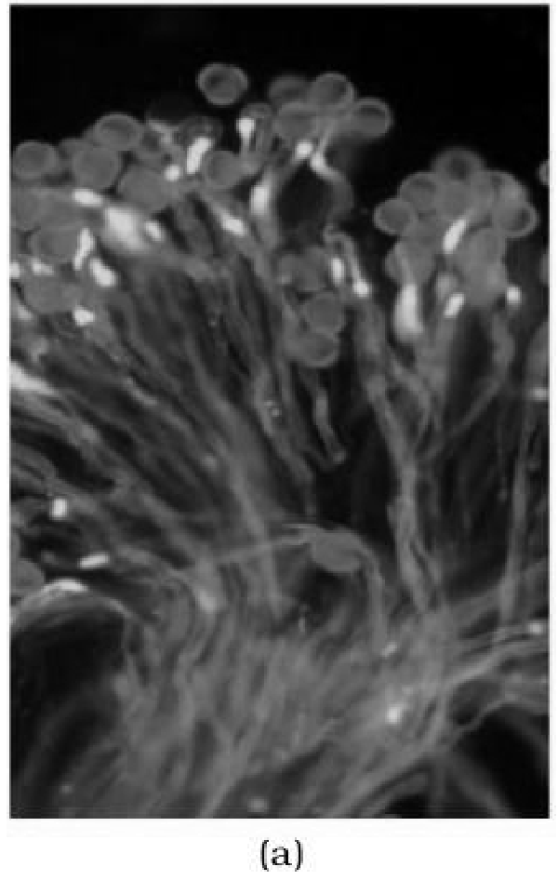 | 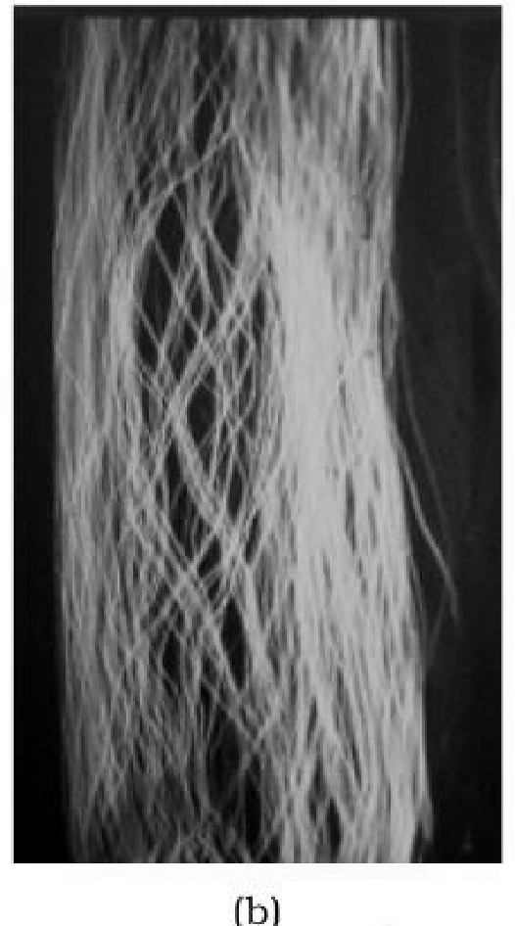 | 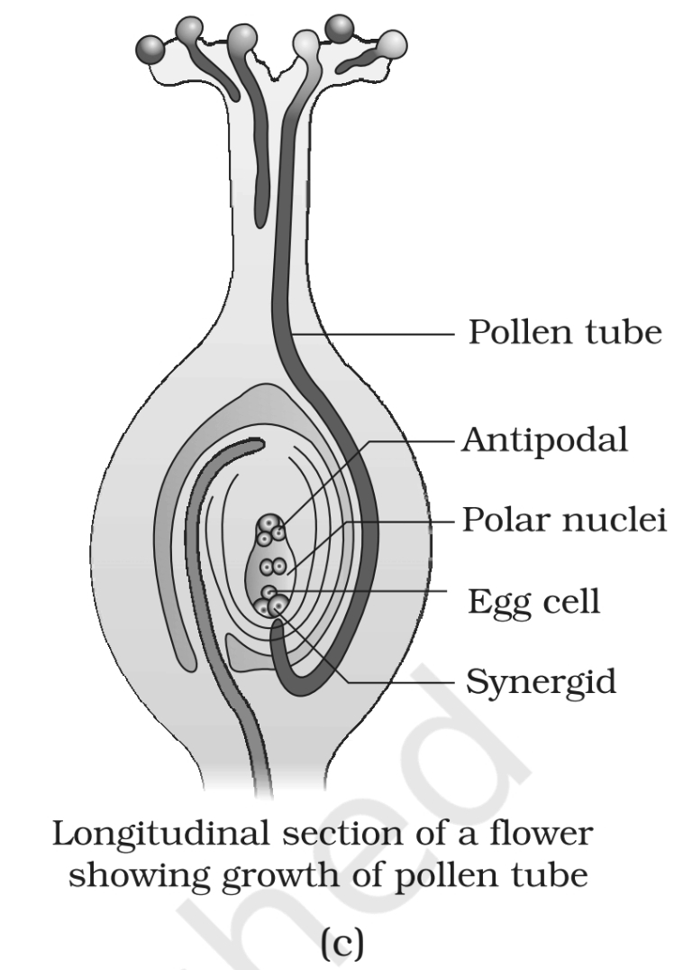 | 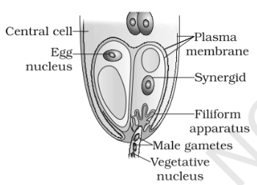 | 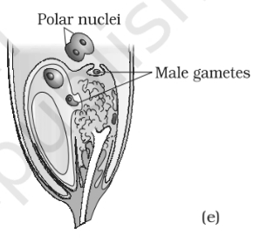
Fig. 1.12 — (a) Pollen grains germinating on the stigma; (b) Pollen tubes growing through the style; (c) L.S. of pistil showing path of pollen tube growth; (d) enlarged view of an egg apparatus showing entry of pollen tube into a synergid; (e) Discharge of male gametes into a synergid and the movements of the sperms, one into the egg and the other into the central cell. Labelled: pollen tube, antipodal, polar nuclei, egg cell, synergid, central cell, egg nucleus, plasma membrane, filiform apparatus, male gametes, vegetative nucleus.
Pollen germination activity: Pollen of pea, chickpea, Crotalaria, balsam or Vinca dusted on about 10 per cent sugar solution forms pollen tubes in 15–30 minutes.
[NOTE] Artificial hybridisation is a major approach to crop improvement: breeders cross different species and often genera to combine desirable traits in commercially superior varieties. If the female parent bears bisexual flowers, emasculation removes anthers from the bud before they dehisce with forceps; bagging with butter paper prevents unwanted pollen from reaching the stigma. When the stigma becomes receptive, dust it with mature pollen from the male parent, rebag and allow fruits to develop. If the female parent bears unisexual flowers, no emasculation is needed: bag buds before opening, pollinate when receptive, and rebag.

1.3 | DOUBLE FERTILISATION

After entering one of the synergids, the pollen tube releases the two male gametes into the cytoplasm of the synergid. Two fusions then follow.
1 | Syngamy. One of the male gametes moves towards the egg cell and fuses with its nucleus, thus completing syngamy. This results in the formation of a diploid cell, the zygote.
2 | Triple fusion. The other male gamete moves towards the two polar nuclei located in the central cell and fuses with them to produce a triploid primary endosperm nucleus (PEN). As this involves the fusion of three haploid nuclei it is termed triple fusion.
3 | The central cell after triple fusion becomes the primary endosperm cell (PEC) and develops into the endosperm, while the zygote develops into an embryo.

• Double fertilisation — since two types of fusions, syngamy and triple fusion, take place in an embryo sac, the phenomenon is termed double fertilisation, an event unique to flowering plants.
1.4 | POST-FERTILISATION : STRUCTURES AND EVENTS

Following double fertilisation, events of endosperm and embryo development, maturation of ovule(s) into seed(s) and ovary into fruit, are collectively termed post-fertilisation events.
1.4.1 | Endosperm

Endosperm development precedes embryo development. The primary endosperm cell divides repeatedly and forms a triploid endosperm tissue. The cells of this tissue are filled with reserve food materials and are used for the nutrition of the developing embryo.
1 | In the most common type of endosperm development, the PEN undergoes successive nuclear divisions to give rise to free nuclei. This stage of endosperm development is called free-nuclear endosperm.
2 | Subsequently cell wall formation occurs and the endosperm becomes cellular. The number of free nuclei formed before cellularisation varies greatly.

[NOTE] The coconut water from tender coconut is nothing but free-nuclear endosperm (made up of thousands of nuclei), and the surrounding white kernel is the cellular endosperm.

Endosperm may either be completely consumed by the developing embryo (e.g., pea, groundnut, beans) before seed maturation, or it may persist in the mature seed (e.g. castor and coconut) and be used up during germination.
1.4.2 | Embryo

Embryo develops at the micropylar end of the embryo sac where the zygote is situated. Most zygotes divide only after certain amount of endosperm is formed. This is an adaptation to provide assured nutrition to the developing embryo.
The early stages of embryo development (embryogeny) are similar in both monocotyledons and dicotyledons: the zygote gives rise to the proembryo and subsequently to the globular and heart-shaped embryos, and finally to the mature embryo.
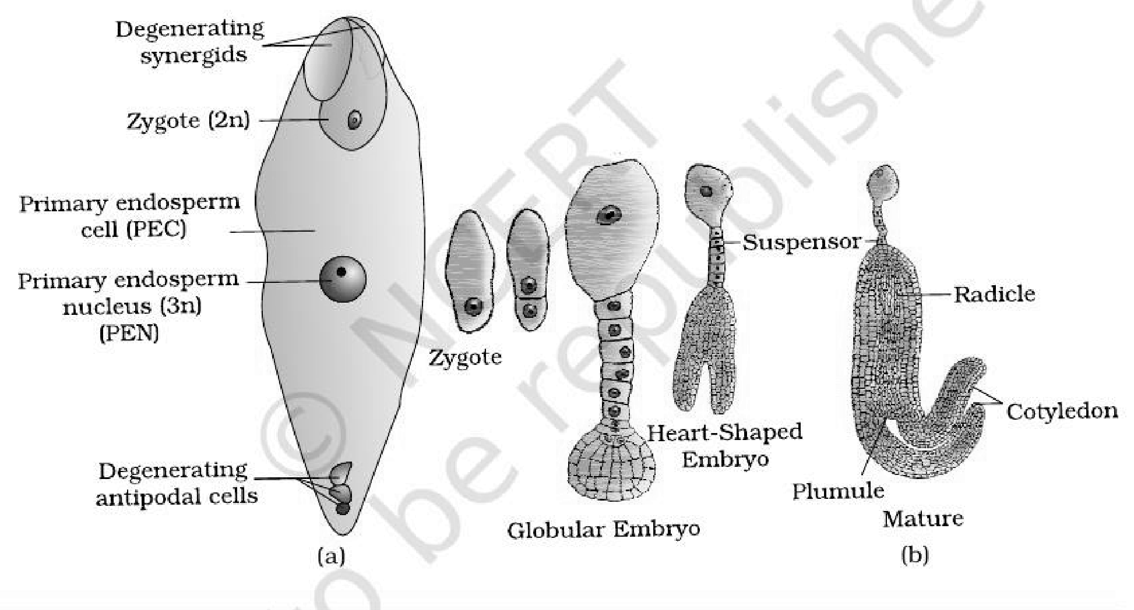
Fig. 1.13 — (a) Fertilised embryo sac showing zygote and Primary Endosperm Nucleus (PEN); (b) Stages in embryo development in a dicot [shown in reduced size as compared to (a)]. Labelled: degenerating synergids, zygote, primary endosperm cell, primary endosperm nucleus, degenerating antipodal cells, suspensor, radicle, cotyledon, plumule, globular embryo, heart-shaped embryo.
Part | Dicotyledonous embryo | Monocotyledonous embryo (grass family)
Cotyledons | Two cotyledons, borne on an embryonal axis | Only one cotyledon; in the grass family the cotyledon is called scutellum, situated towards one side (lateral) of the embryonal axis
Above the cotyledons | The portion of embryonal axis above the level of cotyledons is the epicotyl, which terminates with the plumule or stem tip | The portion of the embryonal axis above the level of attachment of the scutellum is the epicotyl. Epicotyl has a shoot apex and a few leaf primordia enclosed in a hollow foliar structure, the coleoptile
Below the cotyledons | The cylindrical portion below the level of cotyledons is the hypocotyl, that terminates at its lower end in the radicle or root tip; the root tip is covered with a root cap | The embryonal axis has the radicle and root cap enclosed in an undifferentiated sheath called coleorrhiza (also spelt coleorhiza)

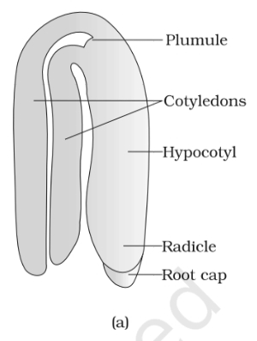 | 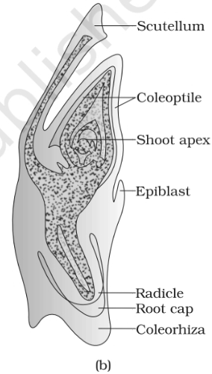
Fig. 1.14 — (a) A typical dicot embryo; (b) L.S. of an embryo of grass. Labelled: plumule, cotyledons, hypocotyl, radicle, root cap, scutellum, coleoptile, shoot apex, epiblast, coleorhiza.
1.4.3 | Seed

In angiosperms, the seed is the final product of sexual reproduction. It is often described as a fertilised ovule. Seeds are formed inside fruits.
A seed typically consists of seed coat(s), cotyledon(s) and an embryo axis.
Seed type | Endosperm at maturity | Examples
Non-albuminous | No residual endosperm, as it is completely consumed during embryo development | Pea, groundnut
Albuminous | Retain a part of endosperm, as it is not completely used up during embryo development | Wheat, maize, barley, castor

• Perisperm — in some seeds such as black pepper and beet, remnants of nucellus are also persistent; this residual, persistent nucellus is the perisperm.
<bullet>• </bullet> Integuments of ovules harden as tough protective seed coats. The micropyle remains as a small pore in the seed coat, which facilitates entry of oxygen and water into the seed during germination.
<bullet>• </bullet> As the seed matures, its water content is reduced and seeds become relatively dry (10-15 per cent moisture by mass). The general metabolic activity of the embryo slows down.
<bullet>• </bullet> The embryo may enter a state of inactivity called dormancy, or, if favourable conditions are available (adequate moisture, oxygen and suitable temperature), they germinate.
From ovary to fruit.
<bullet>• </bullet> The wall of the ovary develops into the wall of fruit called pericarp. The fruits may be fleshy as in guava, orange, mango, etc., or may be dry, as in groundnut, and mustard, etc.
<bullet>• </bullet> In a few species such as apple, strawberry, cashew, etc., the thalamus also contributes to fruit formation. Such fruits are called false fruits. Most fruits however develop only from the ovary and are called true fruits.
<bullet>• </bullet> In a few species, fruits develop without fertilisation. Such fruits are called parthenocarpic fruits; banana is one such example. Parthenocarpy can be induced through the application of growth hormones, and such fruits are seedless.
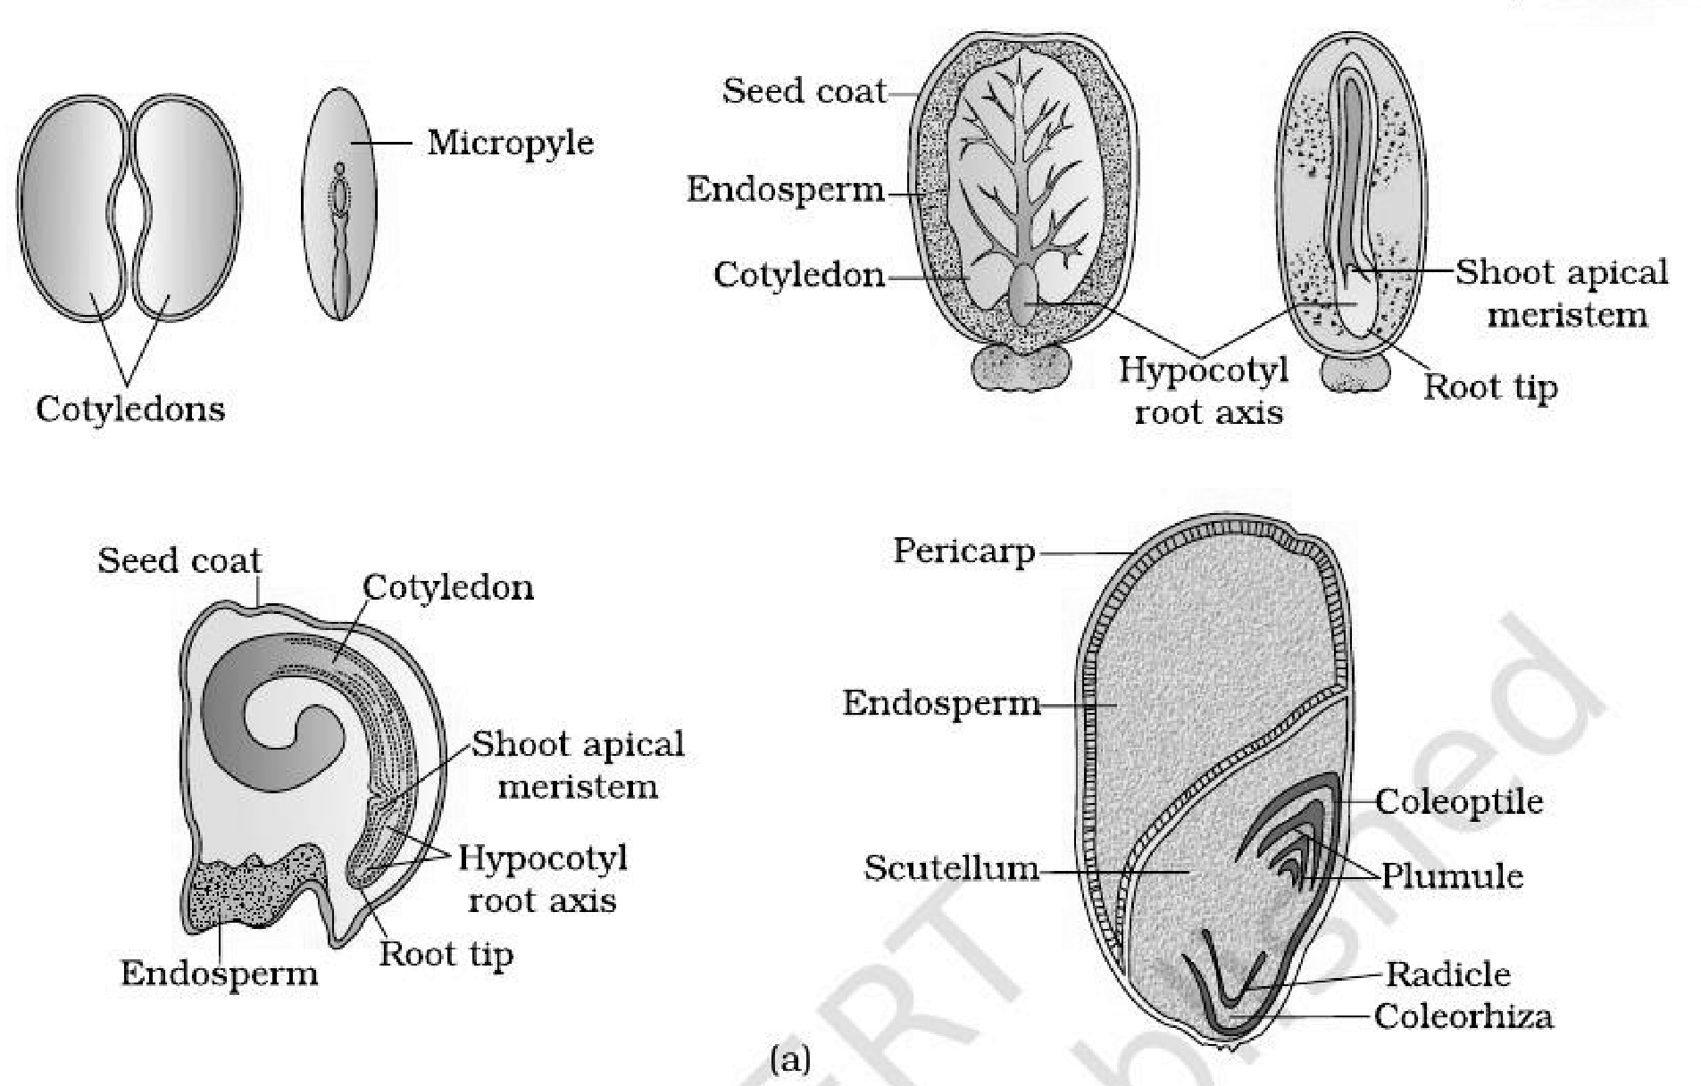
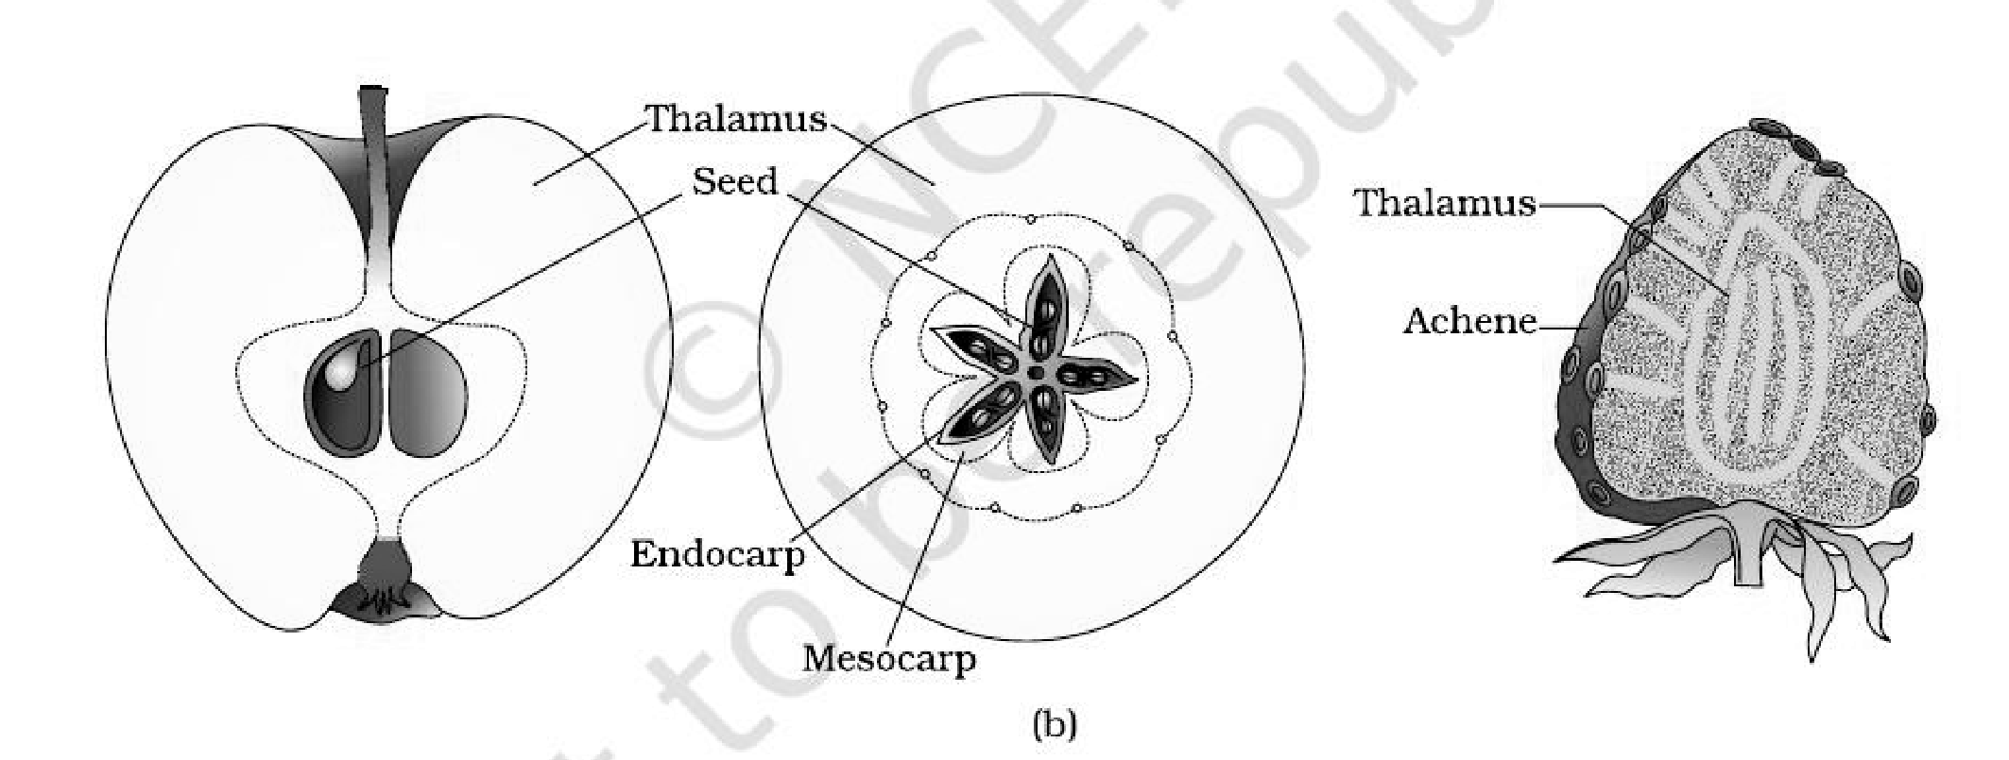
Fig. 1.15 — (a) Structure of some seeds. (b) False fruits of apple and strawberry. Labelled: cotyledons, micropyle, seed coat, endosperm, hypocotyl root axis, shoot apical meristem, root tip, scutellum, coleoptile, plumule, radicle, coleorhiza, pericarp, thalamus, seed, endocarp, mesocarp, achene.
Why seed formation is an advantage.
<bullet>• </bullet> Seed formation is more dependable, because pollination and fertilisation are no longer dependent on water.
<bullet>• </bullet> Seeds have better adaptive strategies for dispersal to new habitats and help the species to colonise other areas.
<bullet>• </bullet> They have sufficient food reserves, and the hard seed coat protects the young embryo.
<bullet>• </bullet> Being products of sexual reproduction, they generate new genetic combinations leading to variations.
Dehydration and dormancy of mature seeds are crucial for storage of seeds, which can be used as food throughout the year and to raise crops in the next season. Some records of seed viability:
Record | Species | Age
Oldest germinated seed | A lupine, Lupinus arcticus, excavated from Arctic Tundra — the seed germinated and flowered | After an estimated record of 10,000 years of dormancy
A recent record of a viable seed | Date palm, Phoenix dactylifera, found during the excavation at King Herod's palace near the Dead Sea | 2000 years old

[NOTE] Orchid fruits each contain thousands of tiny seeds. Similar is the case in fruits of some parasitic species such as Orobanche and Striga.

1.5 | APOMIXIS AND POLYEMBRYONY

Although seeds, in general, are the products of fertilisation, a few flowering plants such as some species of Asteraceae and grasses have evolved a special mechanism to produce seeds without fertilisation, called apomixis. Thus, apomixis is a form of asexual reproduction that mimics sexual reproduction.
There are several ways of development of apomictic seeds.
<bullet>• </bullet> In some species, the diploid egg cell is formed without reduction division and develops into the embryo without fertilisation.
<bullet>• </bullet> In many Citrus and Mango varieties, some of the nucellar cells surrounding the embryo sac start dividing, protrude into the embryo sac and develop into the embryos.
• Polyembryony — occurrence of more than one embryo in a seed.
[NOTE] Why apomixis matters to plant breeders. Hybrid seeds are costly, and the farmer cannot use the hybrid seeds of the produce for sowing, because the characters of the hybrid progeny segregate in the next generation. If these hybrids are made into apomicts, there is no segregation of characters in the hybrid progeny, so the farmer can keep on using the hybrid seeds to raise new crop year after year, and does not have to buy hybrid seed every year.

Recap | QUICK RECAP

<bullet>• </bullet> Flowers are the seat of sexual reproduction in angiosperms. The androecium consisting of stamens represents the male reproductive organs and the gynoecium consisting of pistils represents the female reproductive organs.
<bullet>• </bullet> A typical anther is bilobed, dithecous and tetrasporangiate. Four wall layers — the epidermis, endothecium, middle layers and the tapetum — surround the microsporangium. Cells of the sporogenous tissue undergo meiosis (microsporogenesis) to form microspore tetrads.
<bullet>• </bullet> Pollen grains represent the male gametophytic generation. The pollen grains have a two-layered wall, the outer exine and inner intine; the exine is of sporopollenin and is interrupted by germ pores. Pollen is shed at the 2-celled stage in over 60 per cent of angiosperms, otherwise at the 3-celled stage.
<bullet>• </bullet> The pistil has stigma, style and ovary; ovules arise from the placenta. The ovule's central tissue is the nucellus, in which the archesporium differentiates. A cell of the archesporium, the megaspore mother cell, divides meiotically (megasporogenesis) to give four megaspores, of which usually one is functional (monosporic development). The mature embryo sac is 7-celled and 8-nucleate.
<bullet>• </bullet> Pollination is the mechanism to transfer pollen grains from the anther to the stigma — autogamy, geitonogamy or xenogamy. Pollinating agents are either abiotic (wind and water) or biotic (animals). Outbreeding devices — non-synchrony, spatial separation, self-incompatibility and unisexuality — discourage inbreeding depression.
<bullet>• </bullet> Angiosperms exhibit double fertilisation because two fusion events occur in each embryo sac, namely syngamy (male gamete + egg, giving the diploid zygote) and triple fusion (male gamete + two polar nuclei, giving the triploid PEN).
<bullet>• </bullet> Formation of endosperm always precedes development of the embryo. The mature dicotyledonous embryo has two cotyledons and an embryonal axis with epicotyl and hypocotyl; monocot (grass) embryos have one cotyledon, the scutellum, with coleoptile and coleorrhiza. The ovule becomes the seed and the ovary the fruit (pericarp).
<bullet>• </bullet> A phenomenon called apomixis is found in some angiosperms and results in the formation of seeds without fertilisation. Some angiosperms produce more than one embryo in their seed; this phenomenon is called polyembryony.
Terms | TERMS USED IN THE EXERCISES

The end-of-chapter EXERCISES lean on the following terms and sequences; each is stated here in one place so that a reader of these notes alone can answer them.
Term / item assumed by an exercise | What it means here
Developmental sequence of the male gametophyte | Sporogenous tissue, pollen mother cell, microspore tetrad, pollen grain, male gametes — in that order
Tetrasporangiate anther | Carrying four microsporangia — one at each corner of the tetragonal anther, two per lobe
Archesporium | The tissue differentiating within the nucellus, a cell of which becomes the megaspore mother cell
Monosporic development | Development of the embryo sac from a single (functional) megaspore
Epicotyl vs hypocotyl | Epicotyl is the embryonal axis above the cotyledons, ending in the plumule; hypocotyl is the part below the cotyledons, ending in the radicle
Coleoptile vs coleorrhiza | Coleoptile is the hollow foliar sheath over the shoot apex and leaf primordia; coleorrhiza is the undifferentiated sheath enclosing the radicle and root cap
Integument vs testa | Integument is the protective envelope of the ovule; after fertilisation it hardens into the tough seed coat (testa) of the seed
Perisperm vs pericarp | Perisperm is persistent residual nucellus in the seed (black pepper, beet); pericarp is the wall of the fruit, developed from the ovary wall
Self-incompatibility | A genetic mechanism preventing self-pollen from fertilising the ovules, by inhibiting pollen germination or pollen tube growth in the pistil
Bagging technique | Covering an emasculated flower with a butter-paper bag to prevent contamination of its stigma with unwanted pollen
Triple fusion | Fusion of one male gamete with the two polar nuclei of the central cell — three haploid nuclei in all — giving the triploid primary endosperm nucleus
Importance of apomixis | It mimics sexual reproduction but needs no fertilisation, so hybrid characters do not segregate and hybrid seed can be reused year after year

